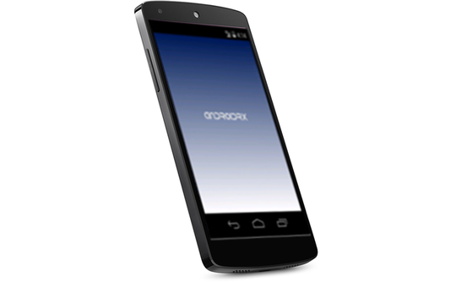AndroidRx

User Guide

Contents

Introduction 3

Provider 3

Logging In 3

Patient List 3

Patient Profile 4

Prescription Details 5

Add Events 6

Patient 7

Logging In 7

Patient Profile 8

Medication Details 9

Setting Schedule Times 10

# Introduction

Welcome to the AndroidRx mobile application. This guide is designed to acquaint the user with the basic functions of the application for creating medication alerts and setting times at which to be notified on a Google Glass device via the GlassRx companion app. The following is divided into two sections: one which highlights the navigations and functionality of the app from a provider perspective, and one which explores the patient-side feature set.

# Provider

AndroidRx allows for providers to schedule flexible medication alerts for their patients in a few simple steps, the details of which are outlined below. Patients will receive these alerts on their GlassRx-equipped Google Glass devices after setting fixed times for the alerts.

## Logging In

To log in as a provider, simply enter an appropriate username-password combination on the log in screen. If such a username has not been provided to you, a new account will automatically be created for you when entering your desired username and password.

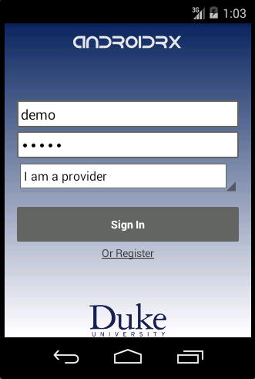

## Patient List

Upon logging in, you will be directed to a list of your currently assigned patients. To filter these results by name, you can select the field at the top of the screen and begin typing the name of the desired patient.

To select a patient, simply press his or her name; you will then be directed to that patient’s profile (See Patient Profile).

To add a new patient to your list of patients, select “Add Patient”. A dialog will appear with a drop-down menu of available patients. Choose from this drop-down list the patient you wish to add.

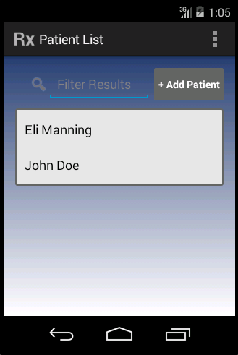 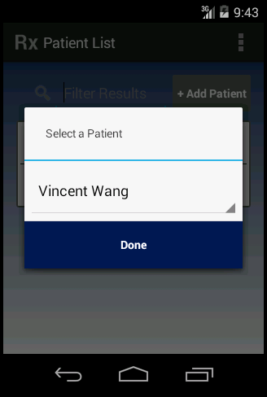

## Patient Profile

Once you’ve selected a patient from your Patient List, you will be directed to his or her profile. This page displays all of the medications which are currently prescribed to this patient.

To obtain details regarding a specific prescription, select the name of the prescription about which you would like to know more (See Prescription Details).

To add a new prescription for the currently selected patient, select the “Add Events” button in the upper right hand corner of the screen (see Add Events).

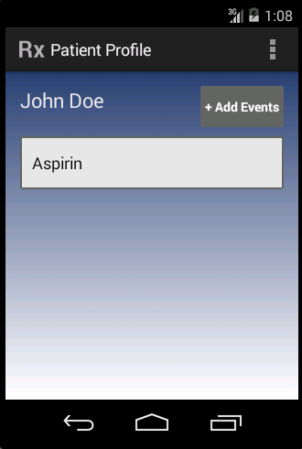

## Prescription Details

After selecting a prescription from a given patient’s current prescriptions, a calendar will appear containing information about the pending alerts scheduled for this prescription. Dates on which the patient is scheduled to take the prescription are indicated by a dot icon on the calendar entry. To see when exactly the patient will be taking prescriptions on a given day, select the date and the lower half will populate with a list of all events scheduled for that day.

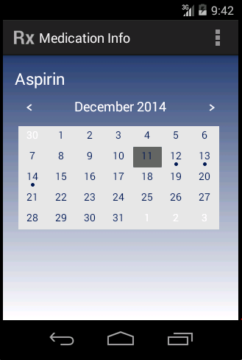

## Add Events

When adding new prescription events, you will be prompted by a screen with fields for entering the name, dose, and dose description for the new alerts. (Note that the dose description is simply a way of describing what the dose actually consists of, such as tablets or eye drops, or if it need to be taken under certain conditions, e.g. with food.)

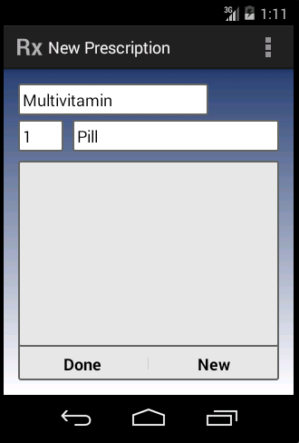

Below these fields, you will see a list (initially empty) containing all of the events staged to be added. Below that are two buttons: “Done”, which adds all staged events, and “New” which allows you to add new prescription events.

When you select “New”, a calendar will appear, allowing you to select the date on which you would like to add a prescription event. After selecting the desired date, a new view will appear which allows you to select times of day at which the patient should take this prescription: morning (5am – 11am), afternoon (11am – 5pm), and evening (5pm – 11pm). If you would like the event to be added to repeat, check the “Repeat” box. You will then be able to indicate whether this event is to be repeated on a daily or weekly basis and for how long you would like it to repeat. When done, press “Set”. This will return you to the original view and the list of staged events will contain the event(s) you’ve just added. To delete events, simply press the “X” on the right hand side of the list element. When finished adding events, press “Done”. This will add all prescription events and will redirect you to the patient’s profile.

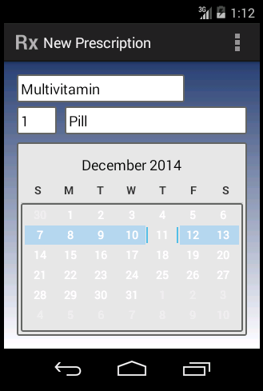 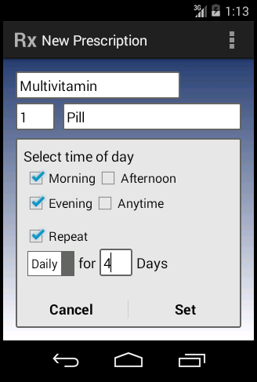

# Patient

For patients, AndroidRx allows for the review and scheduling of medication alerts. Once prescribed and entered by the provider (as described in Add Events), patients can set specific times of day at which to be alerted on the Glass devices. Additionally, patients can view details about the medications which they are currently taking and can add photos of the prescriptions.

## Logging In

To log in as a patient, simply enter an appropriate username-password combination on the log in screen. If such a username has not been provided to you, a new account will automatically be created for you when entering your desired username and password.

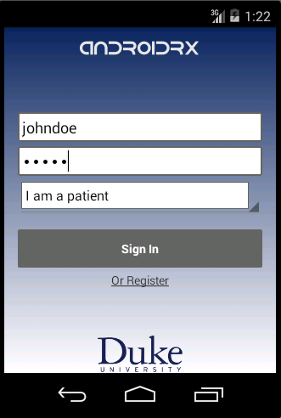

## Patient Profile

Once logged in, you will see a list of medications which you are currently scheduled to take. To get more information about any of these medications, simply select the one about which you would like to know more (See Medication Details).

If, since the last time you accessed the application, your provider has added any prescription events, you will see a second list of those events to be scheduled on the lower portion of your screen. To learn how to allocate these events to specific times, refer to Setting Schedule Times.

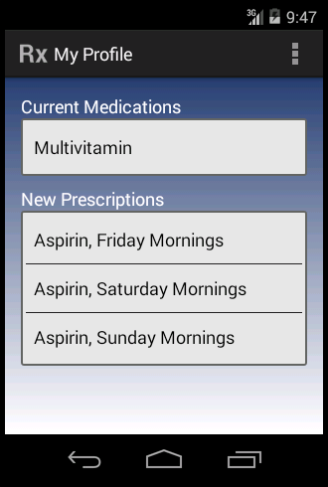

## Medication Details

Once you’ve selected an already scheduled medication, you will be able to review general details about the medication, such as its purpose and side effects, as well as the scheduled alerts for this medication. The former will appear at the top of the screen and the latter at the bottom. Additionally, you can add a custom photo of the medication. To do this, press on the camera icon at the top of the screen. Your device’s camera will then start, allowing you to capture an image. This image will appear in place of the camera icon whenever you review this medication in the future. If you would ever like to retake the picture, simply tap on the current picture and your device’s camera will start again, allowing for another image to be captured in place of the existing one.

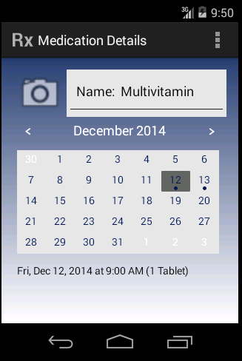

## Setting Schedule Times

To set a specific time at which to take a medication, select the entry from the list of new prescriptions at the bottom of the screen. These entries are grouped by medication-day-time combinations, e.g. all Tuesday morning Ibuprofen prescriptions are grouped together. Once you’ve selected an entry, a dialog will appear with a time picker, allowing you to set the specific time at which you would like to be alerted on your Glass device. Note that the times at which you are eligible to take a certain medication are determined by your provider. They are as follows:

* Morning: 5am – 11am
* Afternoon: 11am – 5pm
* Evening: 5pm – 11pm
* Anytime: 12am – 12pm

For a prescription during one of the times of day listed above, your time options will be constrained to within the ranges listed. Once done, simply press “Done”.

